Mobile Price Prediction using Machine Learning
Aim
To implement a Mobile Price Prediction model using Linear Regression in Python and predict the price of a mobile phone based on its specifications.
Apparatus Required
- Google Colab / Jupyter Notebook
- Python 3
- Libraries:
  - NumPy
  - Pandas
  - Scikit-learn (sklearn)
Theory
Mobile Price Prediction is a supervised machine learning regression problem. The objective is to predict the price of a mobile phone using features such as RAM, storage, battery capacity, and camera resolution.
In this experiment, Linear Regression is used to model the relationship between the mobile specifications and its price.
Advantages:
- Easy to implement.
- Fast and efficient.
- Suitable for continuous value prediction.
Disadvantages:
- Assumes a linear relationship.
- Performance may decrease for complex non-linear data.

Algorithm
- Import the required libraries.
- Create a sample mobile phone dataset.
- Split the dataset into training and testing sets.
- Train the Linear Regression model.
- Predict mobile prices.
- Calculate the Mean Squared Error (MSE) and R² Score.
- Display the predicted prices.

Code (Google Colab)
import pandas as pd
from sklearn.model_selection import train_test_split
from sklearn.linear_model import LinearRegression
from sklearn.metrics import mean_squared_error, r2_score

# Sample Mobile Dataset
data = {
'RAM_GB': [4, 6, 8, 8, 12, 12, 16, 16],
'Storage_GB': [64, 128, 128, 256, 256, 512, 512, 1024],
'Battery_mAh': [4000, 4500, 5000, 5000, 6000, 6000, 6500, 7000],
'Camera_MP': [48, 64, 64, 108, 108, 200, 200, 200],
'Price': [15000, 20000, 25000, 30000, 40000, 50000, 60000, 75000]
}

df = pd.DataFrame(data)

# Features and Target
X = df[['RAM_GB', 'Storage_GB', 'Battery_mAh', 'Camera_MP']]
y = df['Price']

# Split Dataset
X_train, X_test, y_train, y_test = train_test_split(
X, y, test_size=0.25, random_state=42
)

# Train Model
model = LinearRegression()
model.fit(X_train, y_train)

# Predict Prices
y_pred = model.predict(X_test)

# Results
print("Actual Prices:")
print(y_test.values)

print("\nPredicted Prices:")
print(y_pred)

print("\nMean Squared Error (MSE):")
print(mean_squared_error(y_test, y_pred))

print("\nR2 Score:")
print(r2_score(y_test, y_pred))

Sample Output
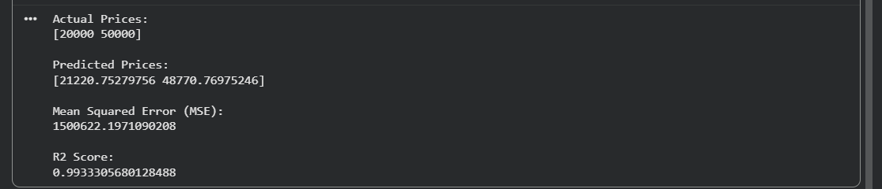
Result
The Mobile Price Prediction model was successfully implemented using the Linear Regression algorithm in Python. The model predicted mobile prices based on specifications such as RAM, Storage, Battery Capacity, and Camera Resolution. The model's performance was evaluated using the Mean Squared Error (MSE) and R² Score.

